Christmas Eve
CHRIST LUTHERAN CHURCH | Lodi, California
December 24, 2023

WELCOME TO WORSHIP
Welcome to Christ Lutheran Church. We pray that your soul will be strengthened by the good news about God’s grace, love, and forgiveness given to us. If you would like to learn more about our church, please speak with our pastor or one of our members after the service.
- Bathrooms are located in the fellowship hall. A changing table is located in the women’s bathroom.
WORSHIP THEME
“Lessons and Carols” is a service that dates back to 1878. The rising popularity of many popular Christmas carols that weren’t often sung in worship services led a few churches to create a special service to celebrate new Christmas hymns and match them to the prophecies, promises, and history of Jesus’ birth. We use this format today to fill our hearts with joy as we celebrate the birth of our Savior.
A service of lessons and carols

Opening Hymn Let All Together Praise Our God| CW 41
Introduction
P: Brothers and Sisters in Christ,
We once again have the privilege of hearing the good news of great joy for all people: the promises God our Father made long ago, and their fulfillment found in the child at Bethlehem. This evening we will rejoice with Mary, wonder with the shepherds, and sing with the angels.
But first, let us pray:
For the people of our own congregation: that they might turn from the darkness of sin and trust in Christ, the Light of the world; O Lord,
C: Hear our Prayer.

P: For our community: that our family, friends, and neighbors might hear of Jesus’ birth and find peace in your promises fulfilled; O Lord,
C: Hear our Prayer.
P: For all people who have suffered loss, who are poor or helpless, sick or sorrowful, or who otherwise struggle to find joy this day; O Lord,
C: Hear our Prayer.
P: For people who do not know the wonderful news that a Savior has been born to them; O Lord,
C: Hear our Prayer.
P: Hear us as we join to pray:
C: Our Father in heaven,
hallowed be your name,
your kingdom come,
your will be done
on earth as in heaven.
Give us today our daily bread.
Forgive us our sins,
as we forgive those who sin against us.
Lead us not into temptation,
but deliver us from evil.
For the kingdom, the power,
and the glory are yours
now and forever. Amen.
GODS WORD Genesis 3:8–15
The first promise of the Savior

CAROL On Christmas Night All Christians Sing| CW 52

GODS WORD Genesis 22:15-18
God promised to bless all nations of the earth through Abraham.

CAROL Let us All with Gladsome Voice| CW 64
GODS WORD Isaiah 9:2, 6-7
The Christ-child, the light of the world, is also the King of kings forever.

CAROL Hark! The Herald Angels Sing| CW 61
GODS WORD Micah 5:2-4
Bethlehem, the city of Israel’s shepherd-king David, is also birthplace of the Good Shepherd.

CAROL Once in Royal David’s City| CW 50
GODS WORD Luke 1:26-35, 38
The angel Gabriel announces to Mary that she would be the mother of the Savior.

CAROL Angels We Have Heard on High| CW 63
GODS WORD Matthew 1:18-25
Jesus’ birth is announced to Joseph, who adopts the Christ-child as his son and gives him his meaningful name.

CAROL O Little Town of Bethlehem| CW 65

GODS WORD Luke 2:8-20
The first witnesses to Jesus’ birth.

CAROL Go, Tell it on the Mountain| CW 57
GODS WORD Matthew 2:1-12
Scholars from far away come to worship the promised Christ-child.

CAROL As With Gladness Men of Old| CW 83
GODS WORD John 1:1–14
The true meaning of Christmas: the eternal God took on human flesh and humbled himself for our salvation.

CAROL What Child is This?| CW 67

CLOSING PRAYER
P: Almighty God, grant that the birth of your one and only Son in the flesh may set us free from our old bondage under the yoke of sin; through Jesus Christ our Lord, who lives and reigns with you and the Holy Spirit, one God, now and forever.
C: Amen.

THE BLESSING
P: The Lord bless you and keep you;
The Lord make his face shine on you and be gracious to you;
The Lord look on you with favor and give you peace.
C: Amen.

closing hymn Silent Night| CW 60

COPYRIGHT INFORMATION
Content requiring a copyright license is reproduced under OneLicense.net #A-718312. All rights reserved. The Common Service: Texts revised from The Lutheran Hymnal, 1941. Music revised by James Engel. Scripture Quotations: From the Holy Bible, New International Version (NIV 1984), © 1973, 1978, 1984 by Biblica, Inc.

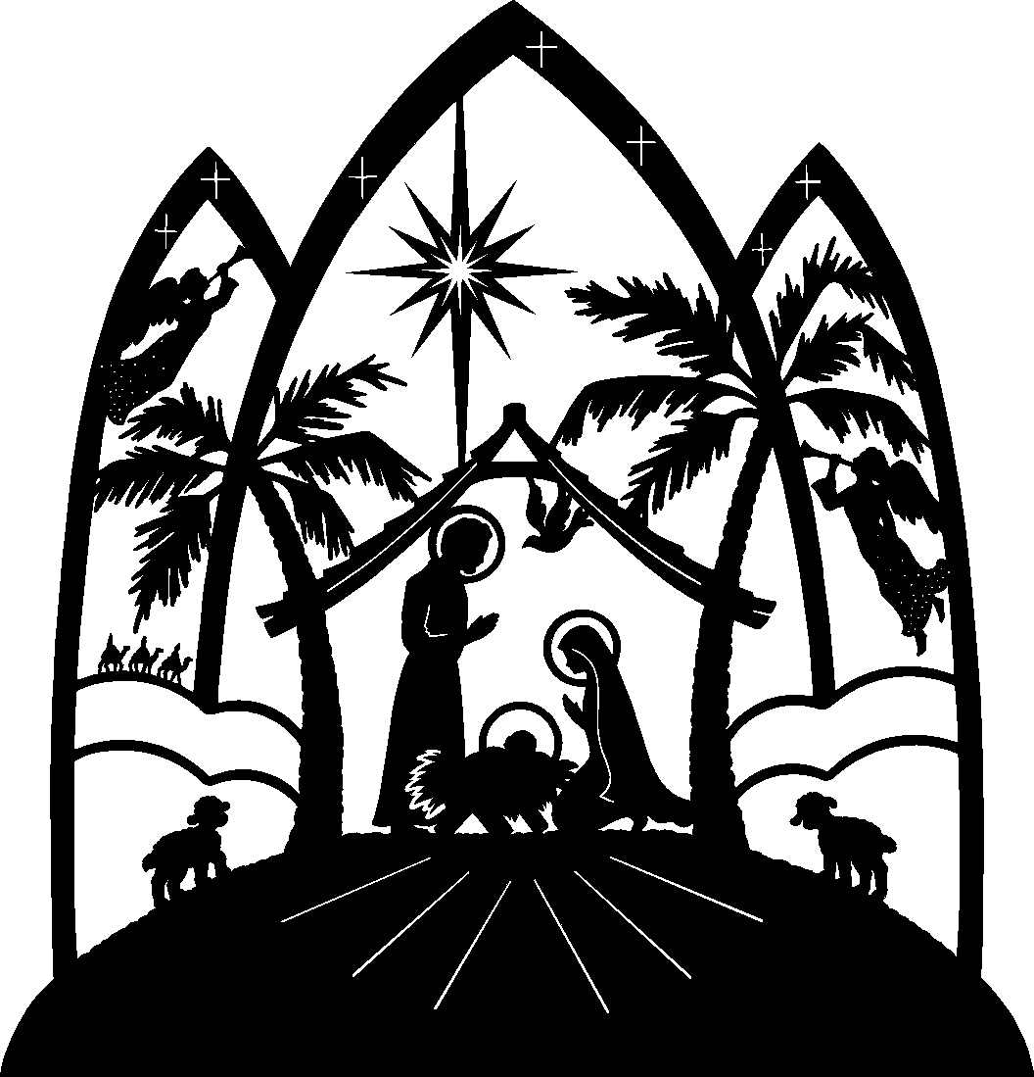

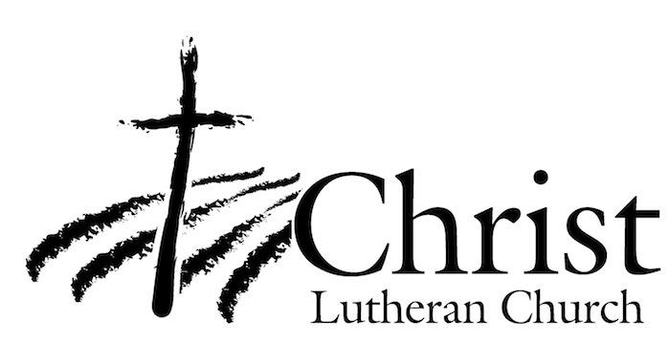
13009 N. Elderberry Ct.
Lodi, CA 95242
www.christlodi.org
209-368-6250
Pastor Timothy Leistekow
WELCOME TO CHRIST EV. LUTHERAN CHURCH!
We preach a message of forgiveness, hope and peace
through the death and resurrection of Jesus Christ.
Families and individuals of all ages will find opportunities
both to grow and to serve.
Our mission statement:
Look what Christ is doing!
He binds us together in fellowship
He gathers us in for worship
He builds us up for service
He sends us out with the gospel

“Now you are the body of Christ,
and each one of you is a part of it.”
(1 Corinthians 12:27)

